**Hot Water Monitoring System**

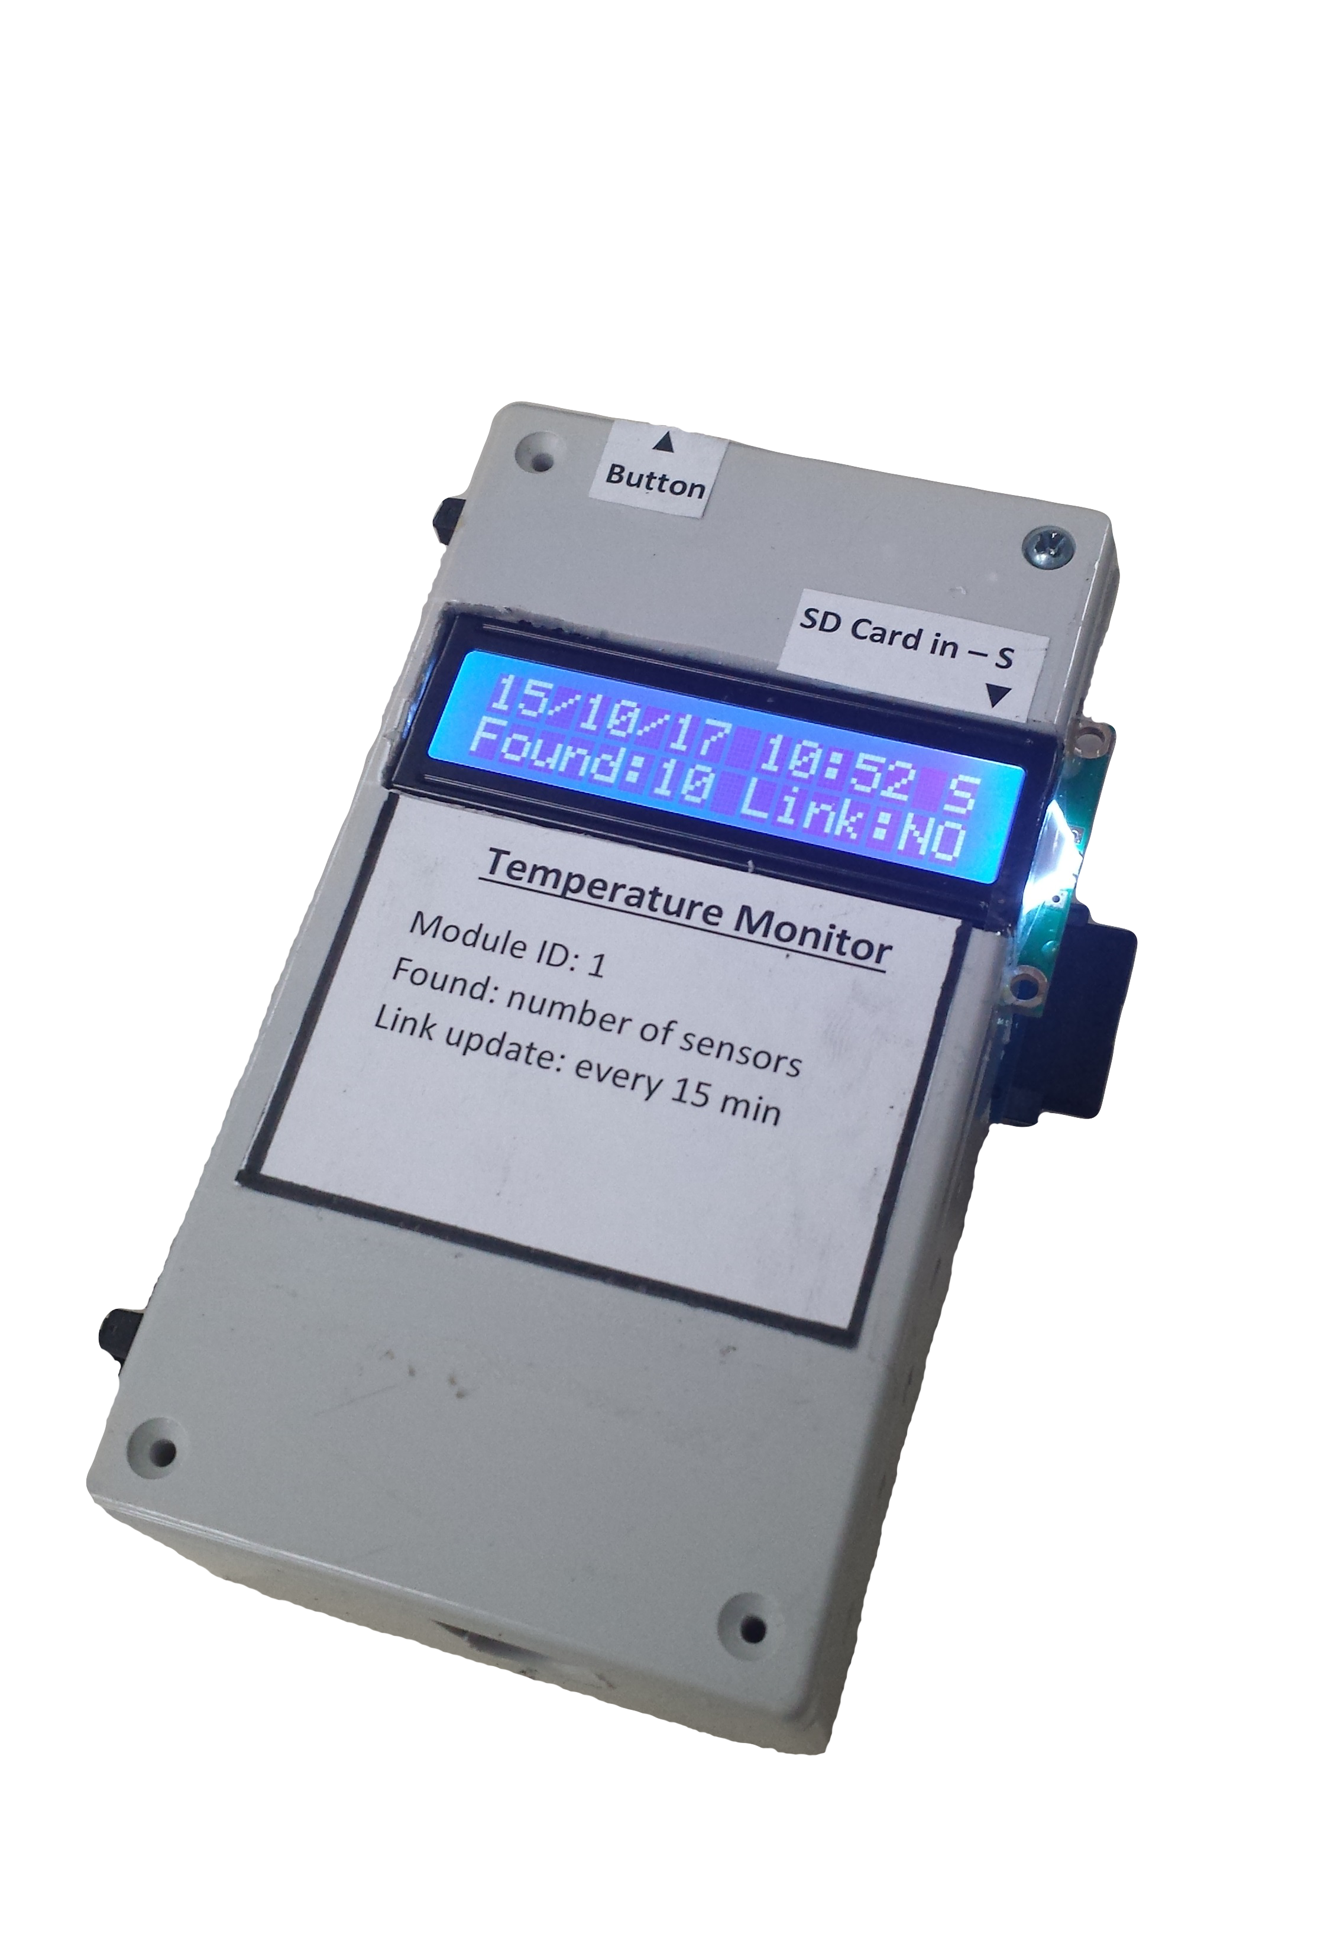

Provided by:   
Arthur Bondar

NSCC Applied Energy Research Lab

Document Prepared on:

October 14th, 2017

**Overview**

Temperature Monitor system is designed to collect temperature data from multiple points of interest on one or potentially a number of hot water tanks. This information can aid in determining efficiency of solar hot water heaters, heat dissipation systems and other research instruments. Commercial use can include monitoring efficiency of house hold heating system. Additionally, this is module is designed to interface with a Monitoring Network for data collection and storage in the data base.

**Features**

* Monitor large quantity of sensor, limited by wire resistance of the Temperature Sensors (tested with 30 sensors).
* LCD Display shows current status of the module, as well as each temperature reading.
* Storage – data backup on SD card with sensor address and measurement, in CSV format.
* Wireless Communication – link of up to 30 meters with a Monitoring Network

**Database Connection**

Temperature Monitor is assigned with the ID of 1 in the Monitoring Network. Using this ID, the module can connect with the server and log its temperature reading in the database. Monitoring Network provides web access to reading from a variety of data acquisition devices. Temperature Monitor follows the protocol of communication with the Network, when data is requested by the server, the monitor streams each sensor’s address and data. Since addresses of One Wire sensors unique, each sensor can be assigned with a meaningful name in the data base, providing distention between monitoring points.

**Components**

|  |  |
| --- | --- |
| Arduino Nano | MCU of choice for this project, it’s a simple to use and small arduino board. The advantage of using this board is its low cost and the fact that it works with 5v logic. The higher voltage allows to expand the length of number of one wire temperature sensors, and allows them to work in “parasitic’ mode (using only data and ground). |
| Temperature sensors (ds18b20) | One wire temperature sensors designed by Dallas. Innovative technology developed by Dallas Corporation allows multiple sensors to be connected on the same bus. Sensors provide temperature reading within 0.5C accuracy and each sensors is assigned with 10bit unique address. |
| Radio Transceiver (nRF24L01) | 2.4GHz radio transmitter developed by Nordic Semiconductor Company. This module provide reliable communication of up to 30 meter, with multiple channels and transceiver on same radio channel. Each nRF24 is distinguished by its unique address which corresponds to given module ID (changed in software). It is used to communicate with the Data base. |
| SparkFun RTC | Real time clock from SparkFun Company, based on DS1307 IC. Used to provide time stamps for data logging. |
| SD card reader | Simple SD card reader which supports SDHC and Micro SD card types formatted as FAT32 or FAT16. |
| LCD display + PCF8574AT expander | Provides secondary used interface with the system (besides the Server). Uses I/O expander to enable communication using I2C. Display shows temperature reading from each individual sensor, as well as system status. |
| Push Button | Used to switch between display windows. |

**Diagram**

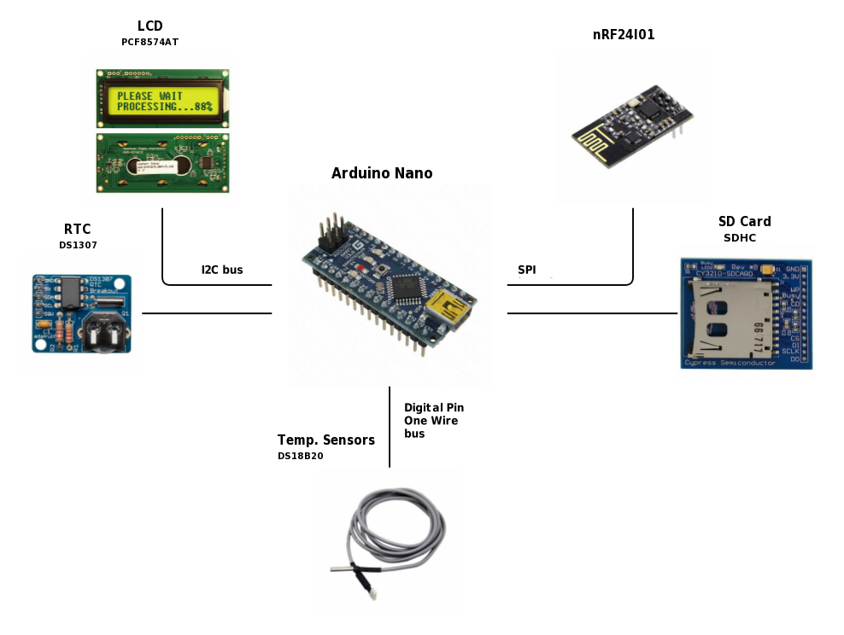

I2C Bus (TWI) – LCD display (with PCF8574AT I/O expander) and RTC both communicate with the microcontroller over Two Wire Interface (TWI or I2C). Since I2C is open collector, a 1k pull up resistors were implemented communication lines. Each module on the Bus has unique 2-byte address, which is used to address each module individually. Connection consist of 4 lines: SDK – Data, SCK – Clock, Vcc and GND

SPI – Serial Peripheral Interface is used to for high communication. SD Card and Radio Transceiver uses this interface and distinguished by the Microcontroller with the use of Chip Select line. Connection consist of MOSI – MCU output to module, MISO – module output to MCU, SCK – clock, CS – Chip select line to indicate which module is addressed. nRF24 also require additional line Chip Enable.

One Wire Bus – Any digital pin on Arduino can be used for this communication (enables in software). This communication protocol is relatively slow, however only requires two lines DATA and GND.

**User Interface**

There are 3 means of data retrieval from the module – information sent to the web server and database of monitoring network, data written on SD card and temperature displayed on the LCD.  
The LCD cycles through its windows using a simple push button on the top left corner of the device. Module status and different tabs are as follows:

Main TabDate and Time – time display set by Internal RTC clock, value can drift when no power provides to the module, thus, need periodic time updates (using time setup program). Note: this time is used for SD back up timestamps only, when module sends data to the data base, the server timestamps the data internally.  
SD card Indicator – One character to indicate when the SD card is detected. Display S when SD card is inserted and nothing (space) when no SD is present.  
Number of Sensors – Displays the number of One Wire devices present on the Bus. Automatically updated by the MCU.  
Link – Indicates connection to the Monitoring Network. If Server requested data within 15 minute period, Link indicates either “OK” or “NO” accordingly (hardcoded in software).

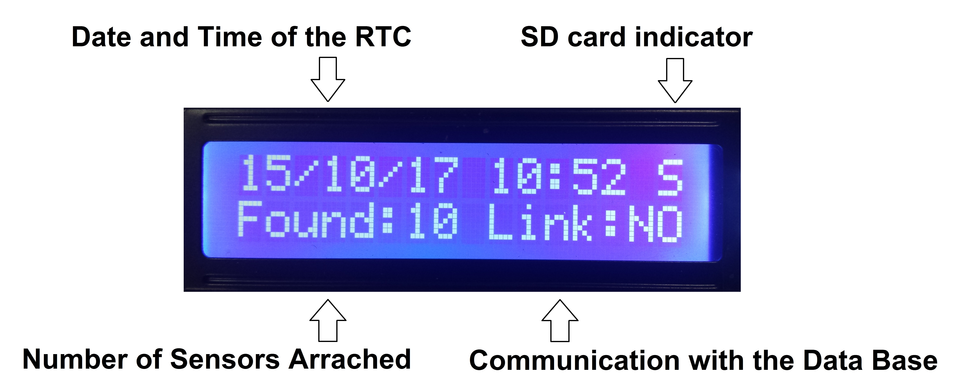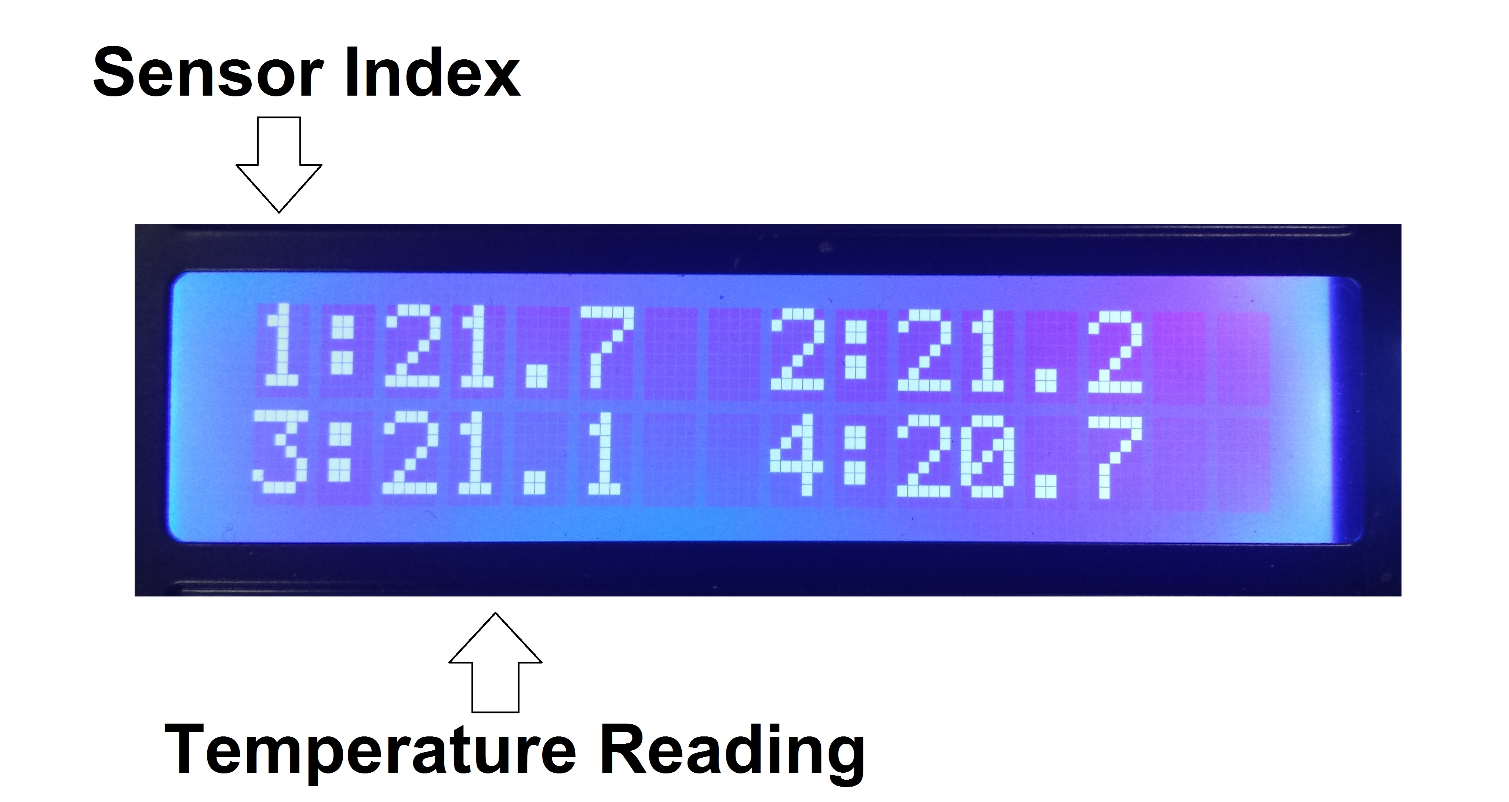

**Program**

Libraries: